**COMPONENTS REQUIRED:**

* Battery 7.4V (3.7Vx2, ICR18650)
* Battery Holder
* Switch
* Arduino Uno
* 2x IR Sensor
* US Sensor HC-SR04+Holder

USE FOR OBSTACLE DETECTION AND AVOIDING

* SG90 Mini Servo
* L298 motor Driver 4*wheel /L293D motor Driver 2*wheel
* Solderless Breadboard

**DIMENSIONS:**

**Length:**

The length of the car can vary depending on the size of the components used, but a common length for a line following car is around 10-12 inches.

**Width:**

The width of the car should be wide enough to accommodate the components such as the motors, wheels, battery and circuit board. A width of around 5-6 inches cm should be sufficient.

**Height:**

The height of the car should be low enough to ensure stability and prevent it from tipping over. A height of around 4-5 inches should be adequate.

**Wheel diameter:**

Smaller diameter wheels of around 4-6 cm can be used.

**Ground clearance:**

The distance between the bottom of the car and the ground should be enough to prevent the car from hitting obstacles. A ground clearance of around 1-2 cm is recommended.

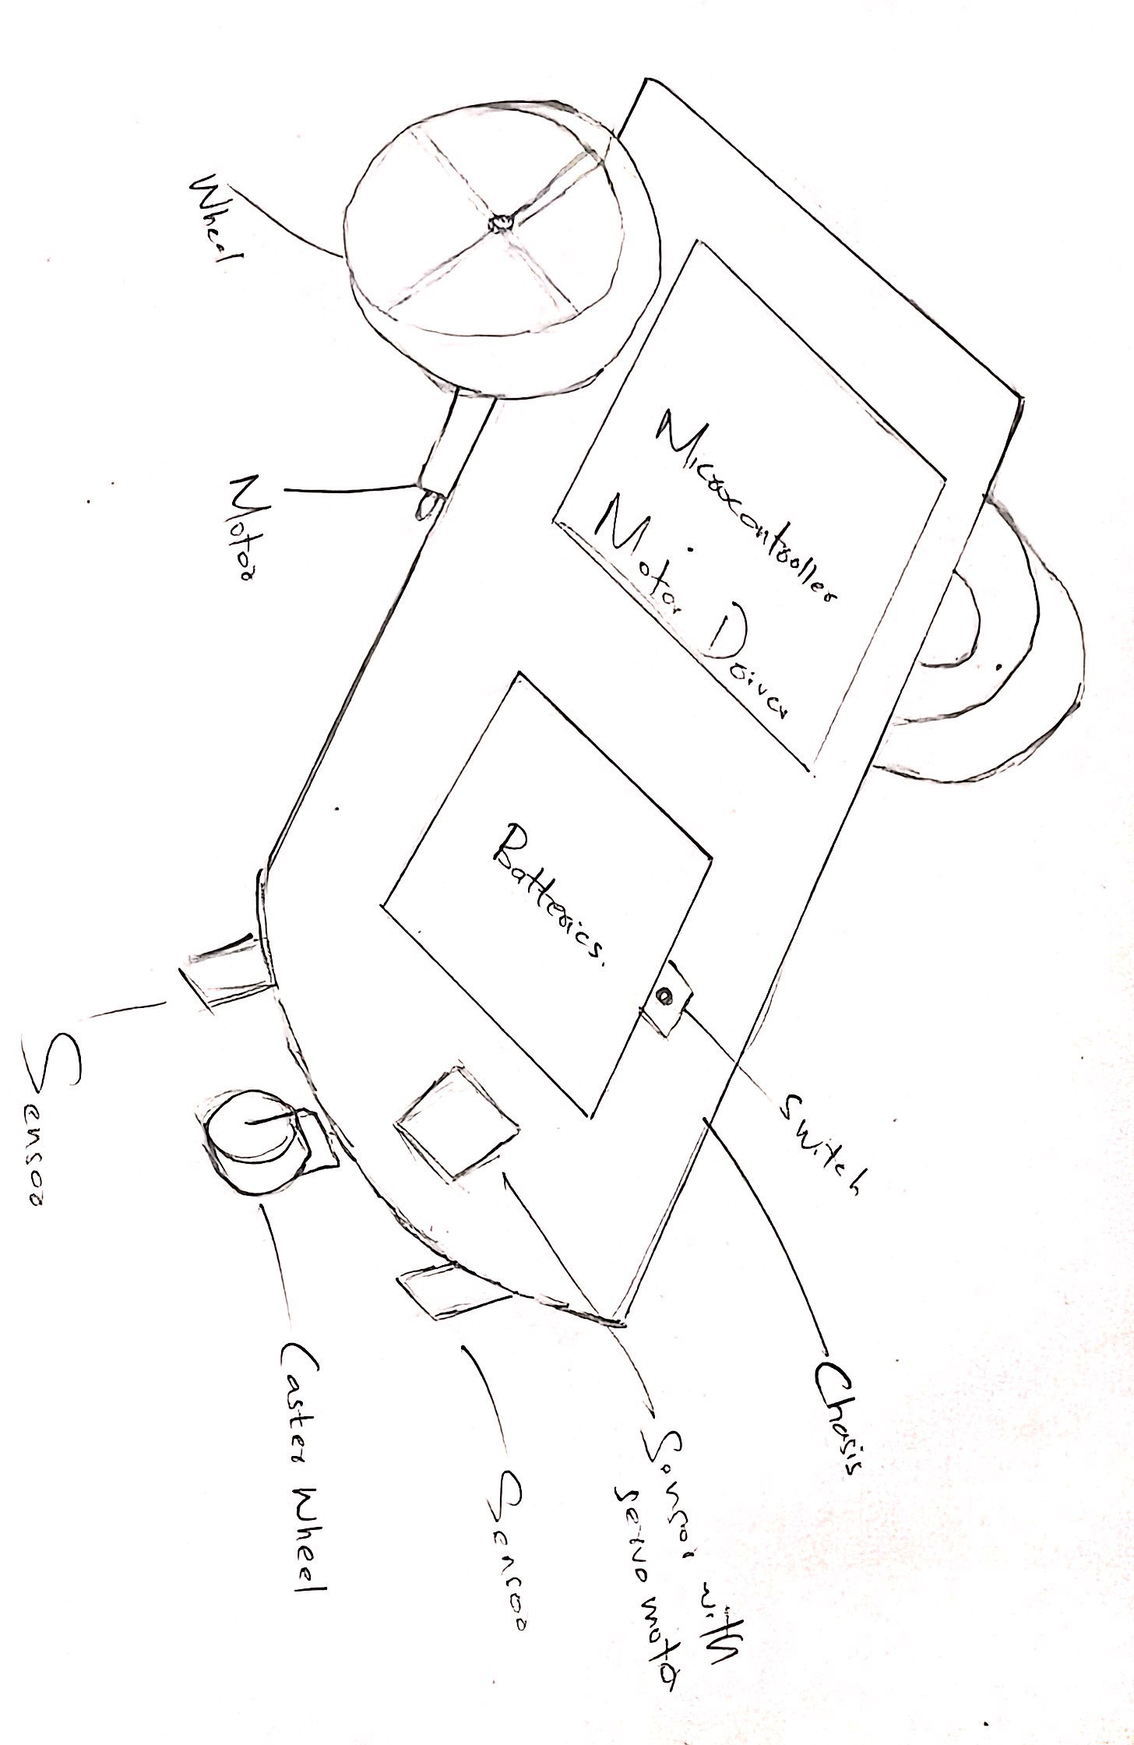**BASIC DIAGRAM:**

